RSU Software Update Work Instructions
Objective
This procedure outlines the steps taken to update the operating system of the Spectra RSU. This procedure assumes user familiarity with the RSU and the supporting equipment and software listed below.
Material Requirements
- Windows PC and Ethernet Cables
- WinSCP or equivalent File Transfer Application
- PuTTY or equivalent SSH Client
- DENSO RSU Release Software Package
- DENSO RSU Config Package
- TrafficCast Spectra RSU
- LCOM POE Injector
- Econolite Cobalt Traffic Controller with Power Cable
- 7-Zip Archiving Utility
- Advanced IP Scanner (Optional)
- Work area with adequate GPS reception
Software Update Setup
- Open Windows Explorer and create an RSU directory on the local disk.
- Move the RSU Release Software and Config Packages to the created RSU directory, typically archived in the 7zip format as rsu_microsd.7z and rsu_configs.7z.
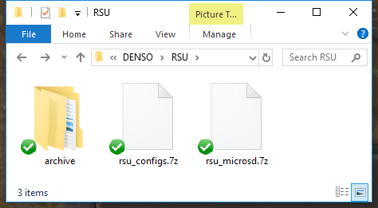
- Right click on each file and left click 7-Zip → Extract Here to extract the contents to the OBU directory. This will create the configs and microsd directories.
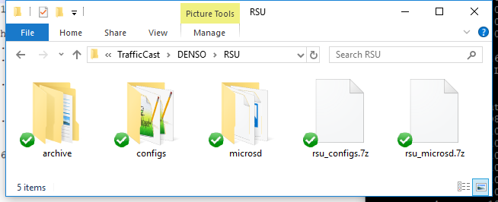
Factory Equipment Setup
- Attach the Cobalt controller “A” power cable to the “A” connector of the controller.
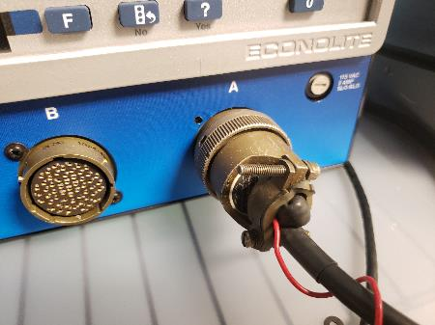
- Plug the “A” power cable into an AC power source, the controller should turn on.
- Navigate to the Ethernet communications page. Set the controller IP address to 192.168.1.32 and Netmask to 255.255.255.0. Set the Ping Server to the IP address of the RSU. The default IP address of the stock RSU is 192.168.1.76.
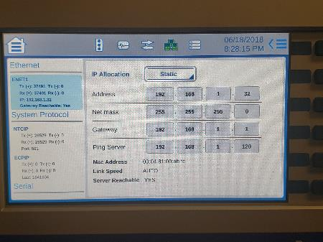
- Plug the AC power cable of the POE injector’s AC adapter to an AC power source, then plug the AC adapter output power cable into the POE injector. The AC adapter LED indicator should light up with power.
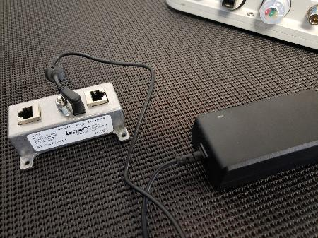
- Connect the RSU to the Data+PWR port of the POE Injector with an Ethernet cable. The RSU Power LED indicator should light up with power.
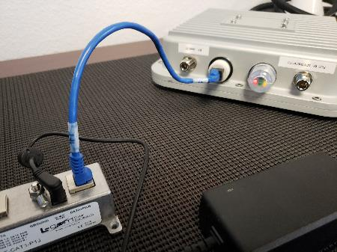
- Connect the POE Injector Data port to Port 1 of ENET-1 (WAN) of the controller with an Ethernet cable.
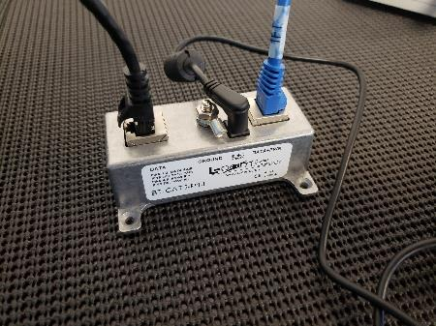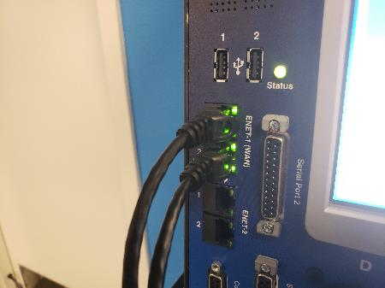
- Connect the computer to Port 2 of ENET-1 (WAN) of the controller with an Ethernet cable. Set the computer IP address to match the subnet of the RSU and controller, i.e. 192.168.1.100.
- Open PuTTY to start an SSH session into the controller. Set the Host Name to econolite@192.168.1.32, Port to 22, Connection Type to SSH, and save the session as “CobaltSM” for future use.
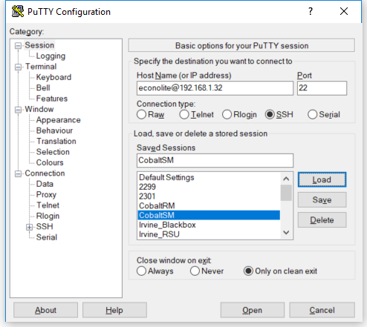
- If asked to accept the SSH key from the controller when connecting, click on Yes to accept and continue.
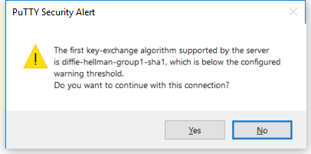
- When prompted to enter the password, type “ecpi2ecpi” as the password and press ENTER. A BASH prompt will appear upon successful login.
- Type the following command “snmpset -v 1 -c public 127.0.0.1:501 1.3.6.1.4.1.1206.3.5.2.9.44.1.1 i 6” and press ENTER to send the SPaT Enable Command. The command should return the OID and integer value “6” upon accepting the command.
- Cycle power on the controller to apply the changes.
Factory Stock RSU Software Update Procedure
- Open WinSCP to start an SCP file transfer session with the RSU.
- In the Login window, select New Site on the left window pane, set the File protocol to SCP, Host name to 192.168.1.76, Port Number to 22 and user name to root. Click on Login to connect to the RSU.
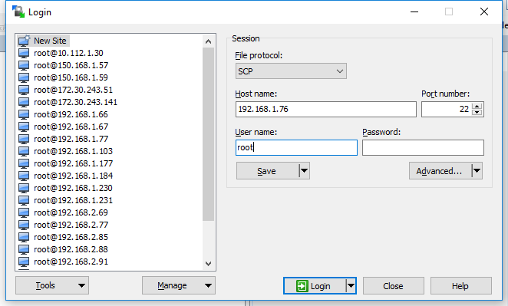
- If asked to accept the RSA key from the RSU when connecting, click on Yes to accept and continue.
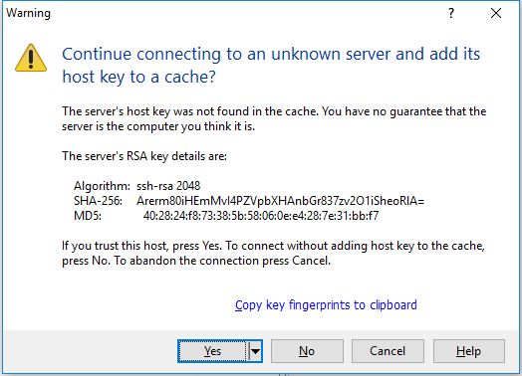
- Navigate the host (left) window pane of WinSCP to the location on the local disk where rsu_configs_<date>.7z was extracted. Navigate the remote (right) window pane of WinSCP to the location /rwflash/configs/.
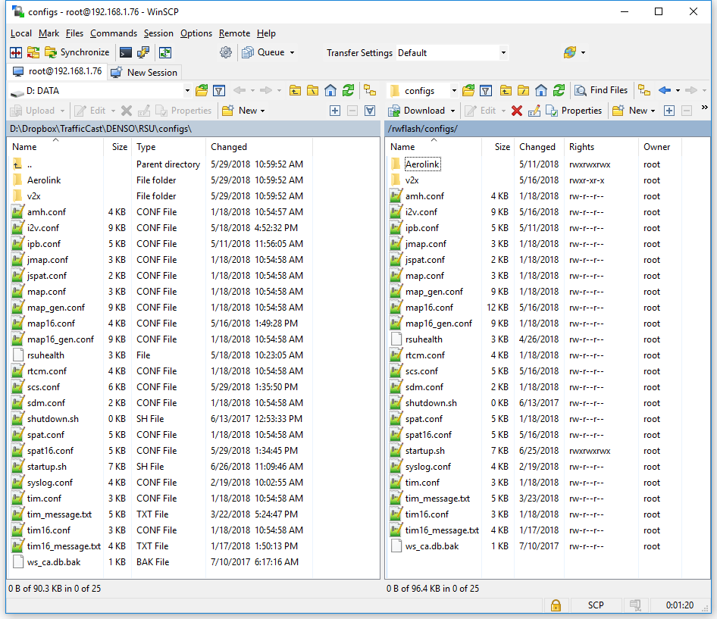
- Left click and drag all local disk config files on the left window pane to select everything, then left click and drag all selected files to the right window pane to transfer files to the RSU.
- When prompted to overwrite the existing files on the RSU, Click on Yes to All.
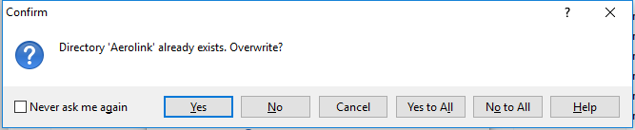
- From the root directory, navigate to /mnt/microsd/.
- On the host window pane of WinSCP, navigate to the location on the local disk where obu_microsd_<date>.z was extracted.
- Left click and drag all local disk microsd files on the left window pane to select everything, then left click and drag all selected files to the right window pane to transfer files to the RSU.
- When prompted to overwrite the existing files on the OBU, Click on Yes to All.
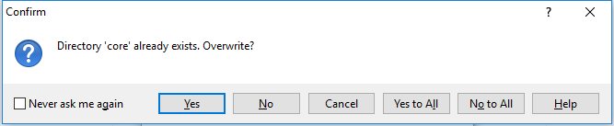
- Open PuTTY to start an SSH session into the RSU. Set the Host Name to root@192.168.1.76, Port to 22, Connection Type to SSH, and save the session as “DefaultRSU” for future use.
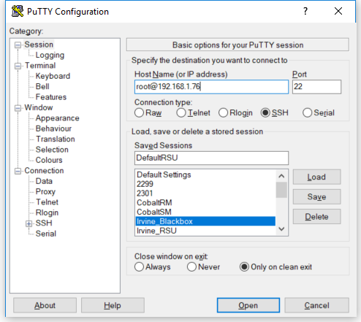
- If prompted to accept the RSA key of the RSU click Yes.
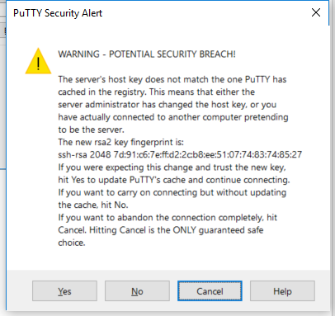
- Once the BASH shell is available, use the command “cd /mnt/cflash/” to change to the “cflash” directory.
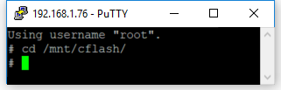
- Run the command “./flash_nor_wsu5900a.sh -v -q -r” to start the upgrade script.
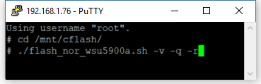
- Press the ENTER key to continue when prompted.
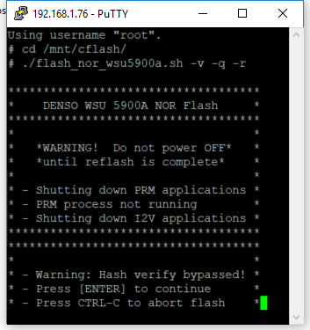
- The RSU will proceed to erase, write, and verify the firmware update then automatically restart. When the RSU restarts PuTTY will report the closure of the network connection.
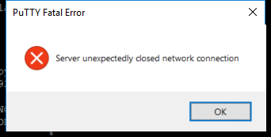
- Reconnect to the RSU by left clicking on the PuTTY icon on the upper left and clicking on Restart Session.
- Once reconnected to the RSU, run “tpstestapp” and hit ENTER to verify the GPS functionality.
- Press the “q” key and ENTER to query the GPS status.
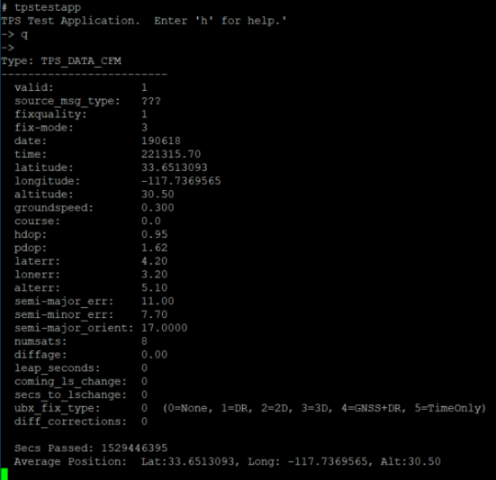
- Check that the Average Position is being reported. Press “x” and ENTER to exit to the BASH prompt.
- Run “mk5stats” to verify the operation of the DSRC radio.
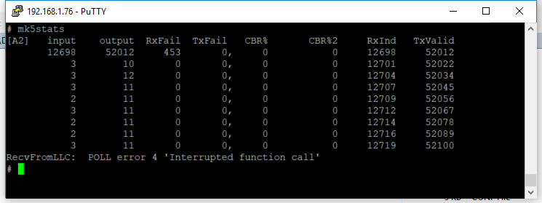
- Each row indicates the number of DSRC messages received and sent per second. Verify that the output column is sending an average of 11 messages per second, these are the 10 SPaT messages plus 1 MAP message generated by the RSU.
- Press Ctrl-C to stop the mk5stats stream and return to the BASH prompt.
- Run “i2vmonitor” to verify the decoding of the controller timing messages.
- Type “1” and press ENTER to view the SPaT message.
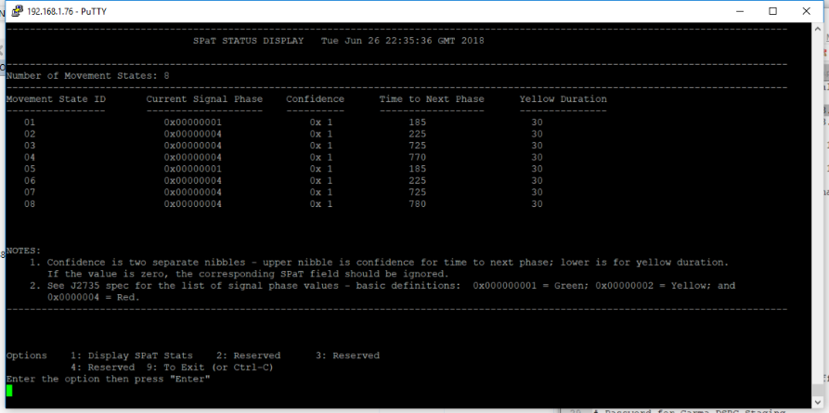
- The “Current Signal Phase” and “Time to Next Phase” fields should be counting down.
- Press Ctrl-C to stop the i2vmonitor stream. Remove power from the RSU when finished.

