OBU Software Update Work Instructions
Objective
This procedure outlines the steps taken to update the operating system of the DENSO Onboard Unit (OBU). This procedure assumes user familiarity with the OBU and the supporting equipment and software listed below.
Material Requirements
- Windows PC and Ethernet Cable
- WinSCP or equivalent File Transfer Application
- PuTTY or equivalent SSH Client
- DENSO OBU Release Software Package
- DENSO OBU Config Package
- DENSO OBU
- Vehicle DSRC Antenna Assembly
- Intrepid Control Systems RAD-Moon Ethernet Converter (For use with Passenger Vehicle OBU)
- 12V Power Supply with Cigarette Lighter Socket Adapter
- 2-to-1 Cigarette Lighter Plug Adapter
- 7-Zip Archiving Utility
- Advanced IP Scanner (Optional)
- Work area with adequate GPS reception
Software Update Setup
- Open Windows Explorer and create an OBU directory on the local disk.
- Move the OBU Release Software and Config Packages to the created OBU directory, typically archived in the 7zip format as obu_microsd_<date>.7z and obu_configs_<date>.7z, where the <date> denotes the software release date.
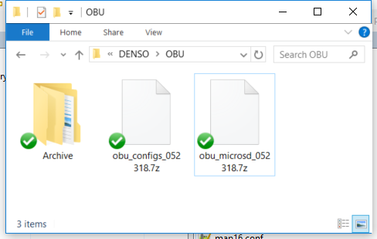
- Right click on each file and left click 7-Zip → Extract Here to extract the contents to the OBU directory. This will create the configs and microsd directories.
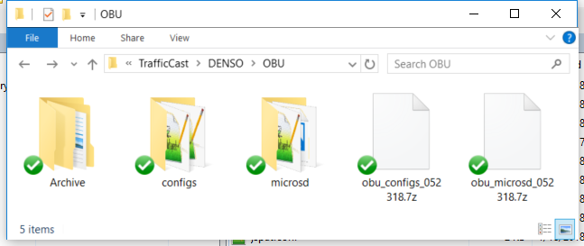
Software Update Procedure
- Make sure there is no power applied to the power supply before connecting equipment.
- Plug the main IO connector of the OBU harness into the OBU as shown.
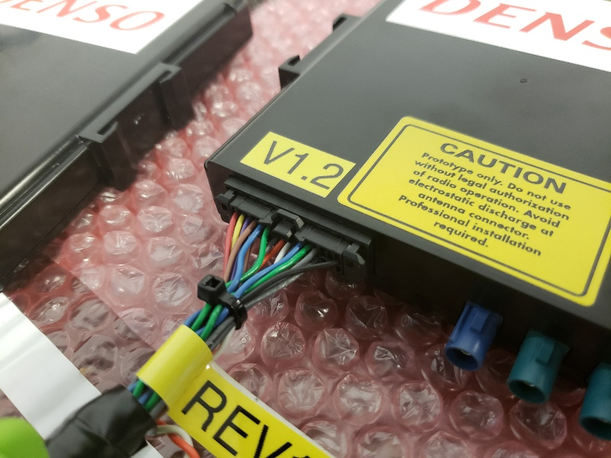
- Plug the DSRC antenna connectors into the color matched Fakra-Z connectors of the OBU.
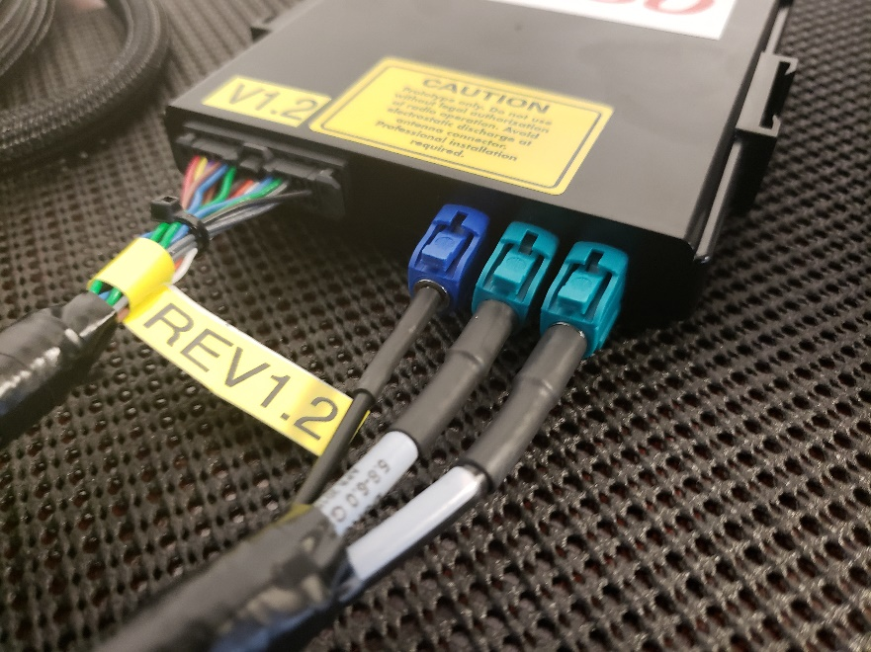
- Plug the OBU RAD-Moon connector of the OBU harness into the RAD-Moon.
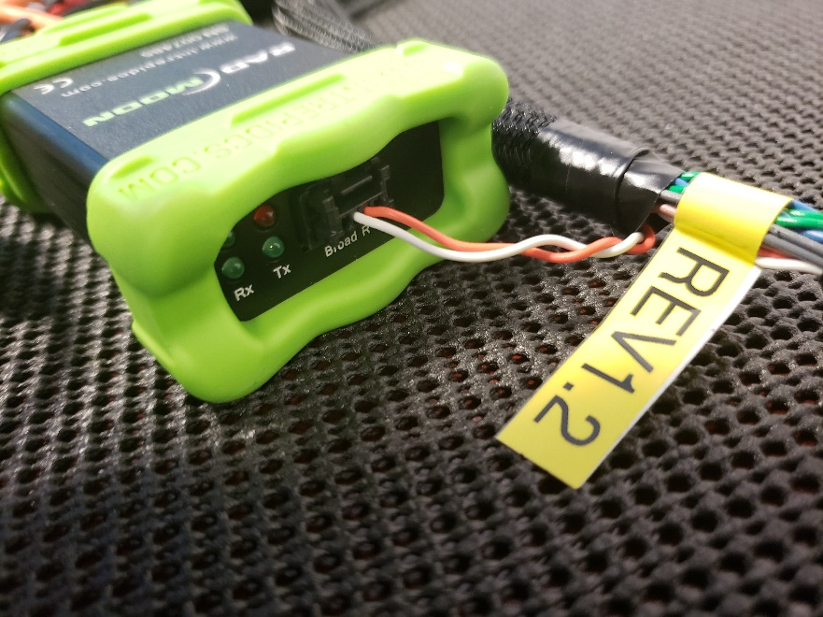
- Plug the Ethernet cable into the RAD-Moon and PC, then plug the Mini-USB connector of the RAD-Moon power harness into the RAD-Moon.
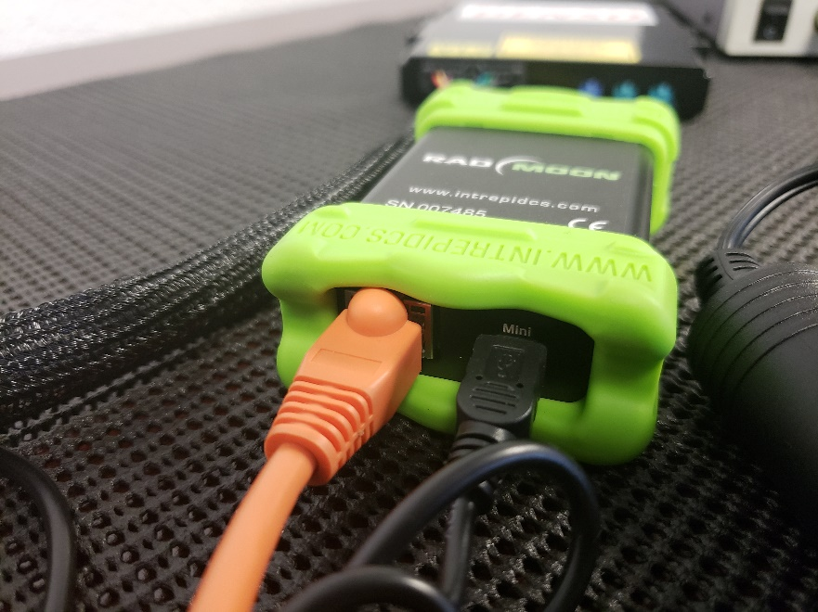
- Plug both cigarette lighter plugs from the RAD-Moon power and OBU harnesses into the 2-to-1 cigarette lighter plug adapter.
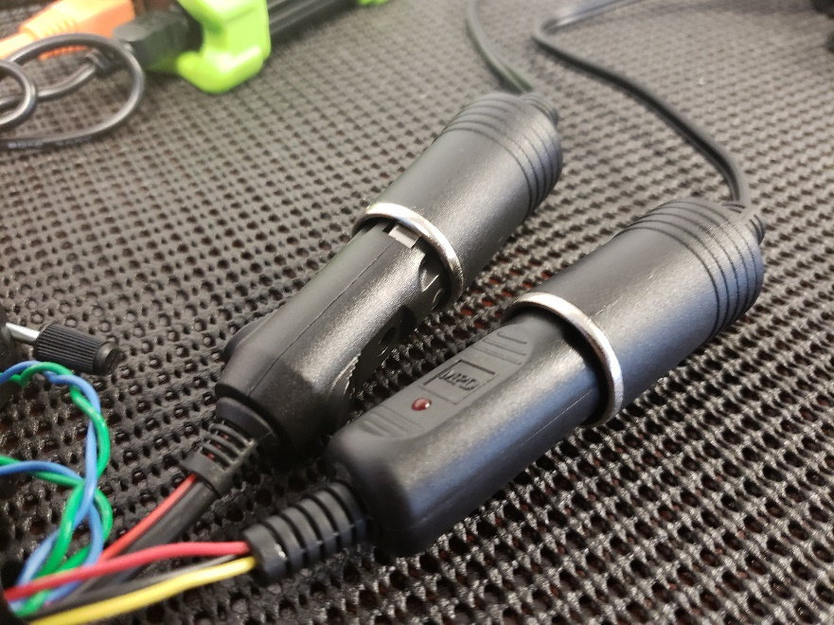
- Plug the 2-to-1 cigarette lighter plug adapter into the socket adapter. Attach the RED and BLACK leads of the socket adapter to the color matched terminals of power supply.
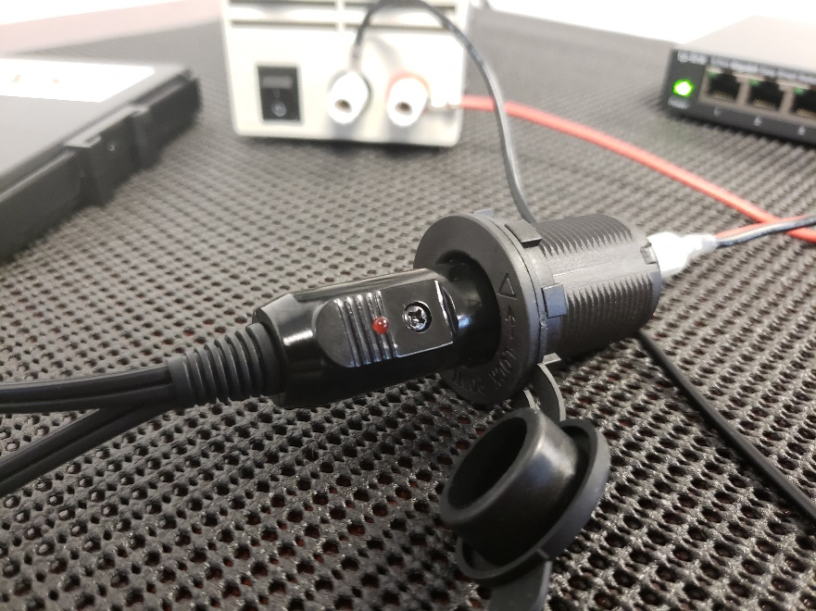
- Apply power the OBU. The LED on the 2-to-1 cigarette lighter plug adapter should turn on.
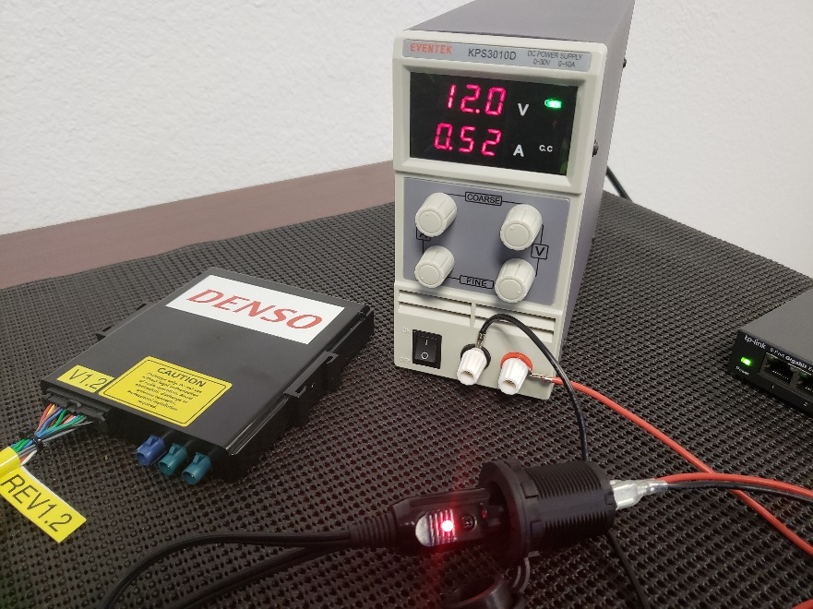
- Open a Command Prompt and ping the OBU. Note the default IP address of the OBU is 192.168.1.77.
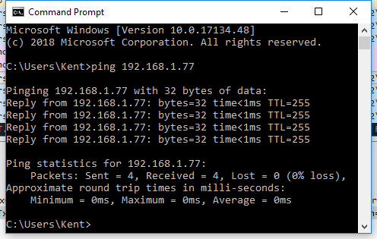
- Open WinSCP and connect to the OBU. Set the file protocol to SCP, port number to 22, username to root and leave the password blank. Click on Save to store the login information for later sessions.
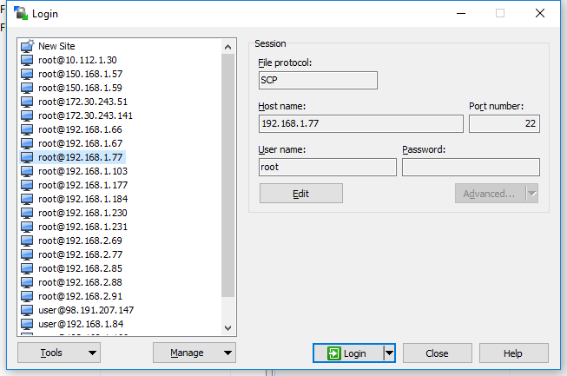
- Navigate the host (left) window pane of WinSCP to the location on the local disk where obu_configs_<date>.7z was extracted. Navigate the remote (right) window pane of WinSCP to the location /rwflash/configs/.
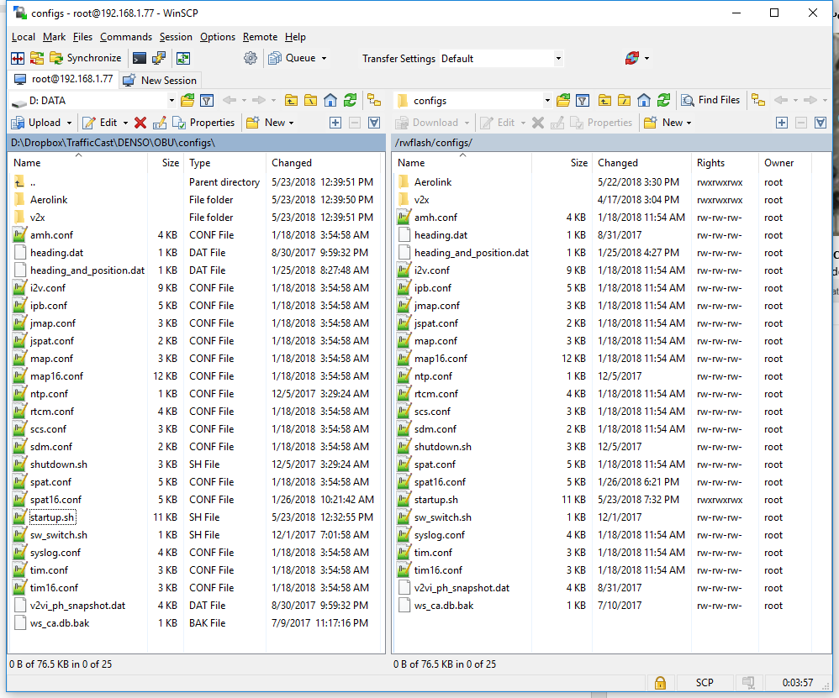
- Left click and drag all local disk config files on the left window pane to select everything, then left click and drag all selected files to the right window pane to transfer files to the OBU.
- When prompted to overwrite the existing files on the OBU, Click on Yes to All.
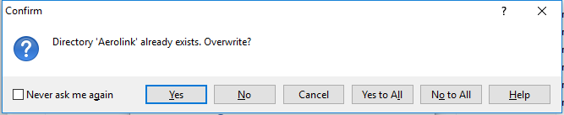
- Navigate to the directory /mnt/microsd/ on the OBU side of WinSCP.
- On the host window pane of WinSCP, navigate to the location on the local disk where obu_microsd_<date>.z was extracted.
- Left click and drag all local disk microsd files on the left window pane to select everything, then left click and drag all selected files to the right window pane to transfer files to the OBU.
- When prompted to overwrite the existing files on the OBU, Click on Yes to All.
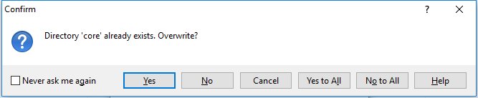
- Open PuTTY and connect to the RSU. Set the Host Name to root@<OBU_IP_Address> (default IP is 192.168.1.77), Port to 22, and Connection type to SSH.
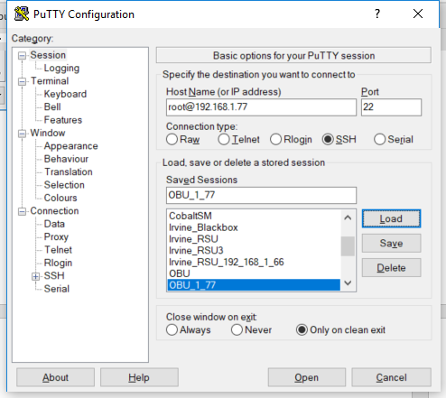
- If prompted to accept the RSA key of the OBU click Yes.
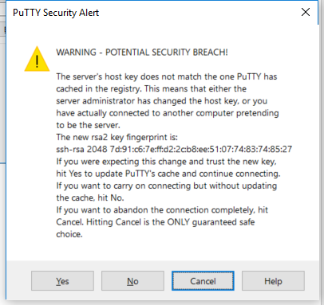
- Once the bash shell is available, use the command “cd /mnt/cflash/” to change directories to cflash.
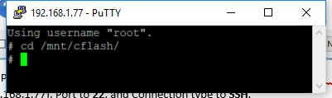
- Run the command “./flash_nor_wsu5900a.sh -v -q -r” to start the upgrade script.
- Press the ENTER key to continue when prompted.
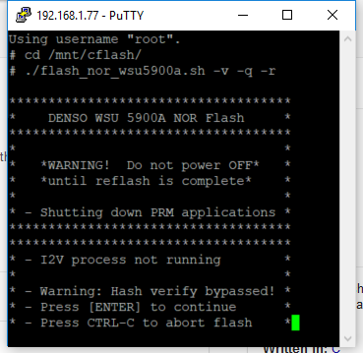
- The OBU will proceed to erase, write, and verify the firmware update then automatically restart. When the OBU restarts PuTTY will report the closure of the network connection.
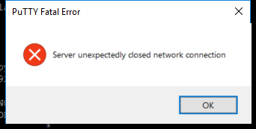
- Reconnect to the OBU by left clicking on the PuTTY icon on the upper left and clicking on Restart Session.
- Once reconnected to the OBU, run “tpstestapp” and hit ENTER to verify the GPS functionality.
- Press the “q” key and ENTER to query the GPS status.
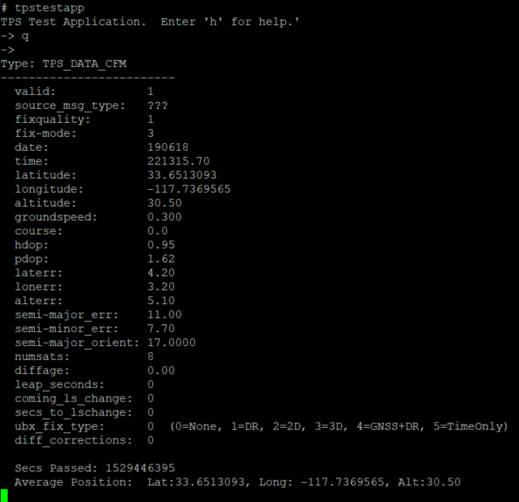
- Check that the Average Position is being reported. Press “x” and ENTER to exit to the BASH prompt.
- Run “mk5stats” to verify the operation of the DSRC radio.
- Each row indicates the number of DSRC messages received and sent per second. Verify that the output column is sending 10 messages per second, these are the Basic Safety Messages generated by the OBU.
- Press Ctrl-C to stop the mk5stats stream. Remove power from the OBU when finished.

