# Stand Alone Server BlueArgus™ Public Access Without a VPN

The purpose of this bulletin is to describe an option for a BlueArgus Stand Alone Server (SAS) to be accessed and viewable via a public IP address. This will allow for users anywhere in the world to utilize the tools that BlueArgus provides without giving full access to the internal network. This option, which utilizes Network Address Translation (NAT), is the most straight forward method which allows many users access without compromising security.

The following process is one of several ways to allow public access to the BlueTOAD SAS; the process may differ depending on the internal network topology***.***

If the BlueTOAD server has an internal IP (LAN IP) of 10.0.1.10, and is behind a network with public IP (WAN IP) of 123.123.123.123, then you can set up a port forwarding rule which is to forward a particular port on the network 123.123.123.123, to the same or different port of 10.0.1.10. As an example, if port 443 (https) is requested, you can forward port 443 of 123.123.123.123 to port 443 of 10.0.1.10. From the Internet, you can then access the web site of 10.0.1.10 by [https://123.123.123.123](http://123.123.123.123/). By registering a URL (e.g.bluetoad.seminolecountyfl.gov ) you should be able to use the registrars Domain Name System (DNS) in order to access BlueArgus via the URL rather than the IP address by giving the registrar your external IP address (123.123.123.123).

In a case where port 443 of 123.123.123.123 is already used, (i.e., already being forwarded to another internal IP) in most cases, you can use another un-used port on 123.123.123.123, such as 8000, and forward that to port 443 of 10.0.1.10. In this case, you access the web site of the BlueTOAD server by [http://123.123.123.123:8000](http://123.123.123.123:8000/). If the route does not support this function, such as the two port numbers must be the same, then there are other ways to make this work, such as adding internal port forwarding of 8000 to 80 at the BlueTOAD server itself.

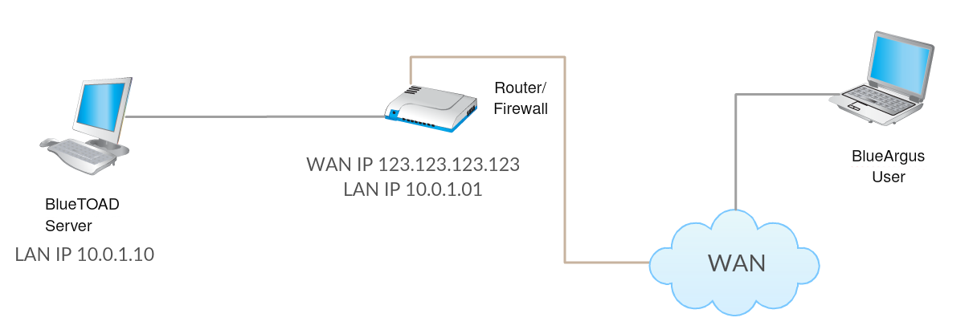

Please visit <http://trafficcast.zendesk.com> or email [bluetoad-help@trafficcast.com](mailto:bluetoad-help@trafficcast.com) for more assistance or if you have any questions.