Traffax Portable V4 Sensor for Data Collection –Quick Start Guide
Traffax Inc.
Revision: 1.1

The portable sensor is an easy to use device for collecting raw data to be used with BluStats software to calculate travel times or perform Origin Destination studies. The unit stores data locally so you can place the unit, power on and come back for your data. The data collection period from startup is reliably 10 to 12 days but if batteries are well cared 14 days is possible. Additional features will affect battery performance.
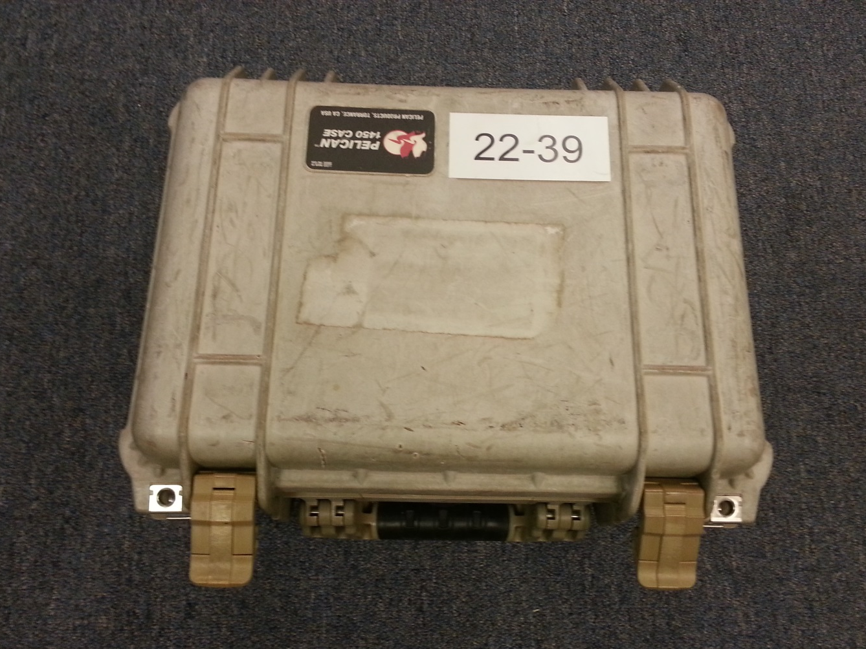
Figure 1 - Sensor External View

Parts:
Included in the waterproof enclosure is everything needed to collect data. The internal components are a battery, a sensor with all needed antennas already connected and placed within the enclosure, a 120V AC charger for recharging the battery after use all enclosed in protective foam.
There is almost never a need to access anything in the enclosure except through the provided cable interfaces. There are four styles of connectors within the case: USB Cable, barrel plug, RJ45 Serial and Anderson Red & Black quick connect power connectors. These connections will be reference throughout the document.
Figure 2 - Sensor Parts

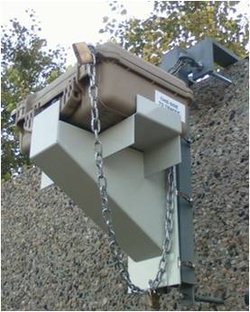Setup:
The key to good study results is a good plan. Placement is the biggest controllable issue. Placement location should be a safe to install location that gives a good view to the road being sampled while avoiding oversampling of nearby roadways. Placement height helps gain detections. If your study is an OD study or done on a less heavily traveled road, it is recommended that the unit is installed on a pole mount at a height of ten (10) to twelve (12) feet above the roadbed.
To use the unit, all that is needed is to connect the two sets of Anderson connectors: red to red & black to black. This connects the battery to the unit and turns the unit on. You will see a small LED turn on and when it displays a slow flashing green (2 seconds on 2 seconds off) the unit is in detection mode. It is recommended that the unit be chained to a fixed structure and both sides locked to avoid tampering or theft.
Figure 3 - Installed Portable Sensor

Takedown:
After unlocking and opening the unit, it is recommended that the Anderson (Red & Black) connectors be pulled apart to turn the unit off to extend battery life and create a clear time block for your study data. Re-latch the case so the sensor is protected during transport.

Collecting your Data:
Data can be retrieved only while the unit is running. If the gear was left in the field long enough for the automatic cutoff to trip, the battery charger will have to be plugged in to re-charge the battery and power the unit while data is being removed.
With the unit running, to retrieve data you will need a typical thumb drive (aka USB flash drive) with an A male adapter that contains a special retrieval file. The retrieval file acts to validate authority to collect data from the unit so please be thoughtful when distributing a copy.
Simply insert the thumb drive with USB A Male connector into the cable with a USB Female connector. (NOTE: drives larger than 4 GB may or may not work) The LED will go solid green for 10 or more seconds and then return to flashing green. At this point, the USB thumb drive will contain any data that was on the local storage and can be disconnected from the sensor. The information from the sensor will be in a folder labeled using the MAC id of the sensor.
Note - If the green light stays on longer than 1 minute, remove the USB drive and re-insert. If the light continues to stay solid, please send the contents of the USB drive to Traffax. There is a log file on the USB that will contain information on the error on the sensor.
It is strongly recommended that you immediately copy the data from the thumb drive to your computer!
Once to have all your data safely stored on your computer you can modify the special file to delete the data from sensor local storage.

Editing the Retrieval File:
A default retrieval file was supplied with your units. You can store a local cost of the default master on your computer. If you need a replacement, a replacement can be emailed. There are two files of concern when uploading the information, the “userSettings.json” and the “configUSB.csv”.
The file “configUSB.csv” is a file that determines what operations are to be run on various sensors. The file can be opened in excel for editing. The file contains flag for operations that happen when the USB drive is inserted into the sensor. Below is a list of the flags/operations that can be performed.
Figure 4 - configUSB.csv in Excel

Variable | Description
Sensor Ethernet MAC IDs | Sensor Identifier that allows operations to be customized for certain sensors. If the MAC id of the sensor is not in the list, then the operations for the MAC id “FFFFFFFFFFFF” will be performed on the sensor. Note quotes are required around the MAC ID due to excel.
Settings | Flag to indicate whether to upload the settings file “userSettings.json” to the sensor from the USB.
Upgrade | Flag to indicate whether to upload an upgrade file to the sensor from the USB.
Archive Download | Flag to indicate whether to download the archived zip files from the sensor to the USB.
Running Files Download | Flag to indicate whether to download the current running files from the sensor to the USB.
Project Name | This operation will change the project name in the sensor settings to match what is input. If the value is left blank, then no changes are made.
Sensor Name | This operation will change the sensor name in the sensor settings to match what is input. If the value is left blank, then no changes are made.
Archive Delete | Flag to indicate whether to delete the archived files from the sensor.
Download GPS Test | Flag to indicate whether to download the GPS testing file from the sensor to the USB.
Delete GPS Test | Flag to indicate whether to delete the GPS testing file from the sensor.

The “userSettings.json” contains settings to load onto the sensor. There are many features built into the sensor, which have various requirements (ie. E-mail requires an internet connection).The configuring of the sensor for additional features is outside the scope of this document.

Battery Care:
As soon as you can after use, the batteries should be fully recharged. 48 hours is the recommended charging time to insure maximum charge.
If the unit has not been used for a month after full 48 hour charge, a top up charge of 24 hours is a good practice to get maximum useful life from the battery.
The sensor is sent with a battery charger. Simple connect the AC to DC converter into a plug and connect to the battery’s barrel plug. The charge controller is contained within the battery and will ensure that the battery is not damaged by overcharging.

Information from your Data:
The data from all sensors in your study will need to be loaded into BluStats software. The 64 bit Windows version can be downloaded https://app.box.com/s/r6eze0wete3dm677aw8s54bmscrctty9
Note: this link might change so if you have problems, please check for a new link in the support section at http://www.trafficcast.com/bluetoad.html#who-we-are
There is a user guide for using BluStats software that is included in the download.

